DIRECTORATE OF CORPORATE SERVICES
ORGANOGRAM
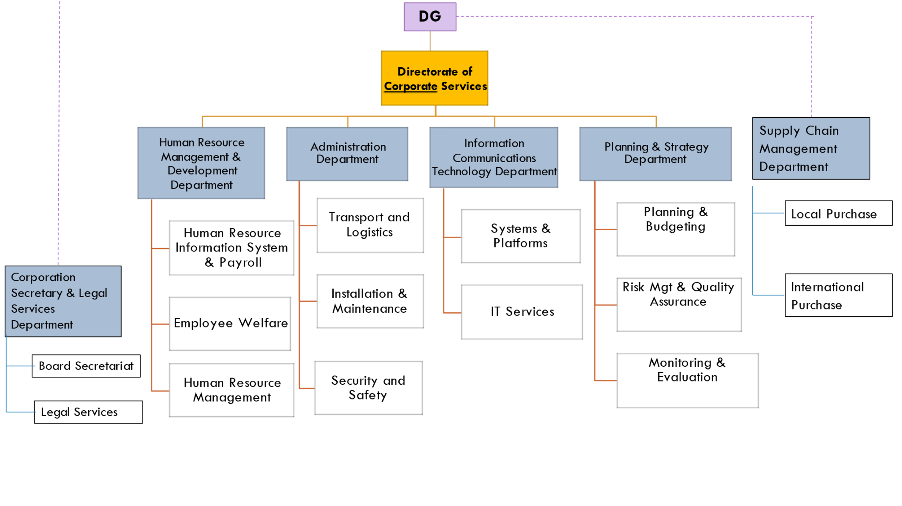

1.0 DIRECTORATE OF CORPORATE SERVICES
- Rationale
The mandate of the directorate is anchored in Legal order No 273 of ST&I Act No. 28 of 2013 Section 5(m) which requires that the organization performs any other function which is incidental to the performance of foregoing functions. The Directorate is responsible for providing leadership and coordination of Human Resource Management & Development, Administration, Information Communications Technology, and Planning & Strategy.
- Functions
The Directorate is responsible for the following key functions: -
- Coordinate Human Resource Management, Administration, Information Communications Technology, and Planning & Strategy activities in the Institute;
- Initiate the development of policies, plans and strategies in the functional areas of Human Resource Management, Administration, Information Communications Technology, and Planning & Strategy;
- Foster a culture that promotes team capability and reflects the values which facilitate performance, professionalism and innovation by staff throughout the institute;
- Oversee planning, directing and executing all human resources strategies, policies and plans;
- Ensure effective implementation and compliance with all legislative requirements relating to corporate services;
- Coordinate the institute’s Information management Systems and security;
- Coordinate technology infrastructure in line with the institute’s goals and changing technologies;
- Provide technical, strategic and policy advice on Information Communications Technology matters and implementation of various ICT work processes, procedures and other administrative related matters;
- Coordinate corporate performance management process of all the directorates of KIPRE
- Develop and oversee the implementation of the institutional budgetary requirements
- Ensure conducive work environment in the institute;
- Physical security; and
- Oversee Development, review and implementation of communications strategy to support the Institute’s objectives;

- Staff Establishment
In order to execute the above functions, the Office ot the director will be staffed as follows:
Table 1: Establishment of the Office of Director Corporate Services
S/No. | Designation | KIP Grade | Proposed | Inpost | Variance
 | Director, Corporate Services | 2 | 1 | 0 | 1
 | Senior Office Administrative Assistant/Office Administrator | 7/6 | 1 | 0 | 1
 | Office Assistant | 10/9 | 1 | 0 | 1
 | Driver/Senior | 9/8 | 1 | 0 | 1
 | TOTAL |  | 4 | 0 | 4

The Corporate Services directorate will be organized into the following Departments:
- Human Resource Management and Development Department;
- Administration Department;
- Information Communications Technology Department;
- Planning & Strategy Department;

1.0.1 HUMAN RESOURCE MANAGEMENT AND DEVELOPMENT DEPARTMENT
- Rationale
The mandate of the department is anchored in Legal order No 273 of ST&I Act No. 28 of 2013 Section 5(m) which requires that the organization performs any other function which is incidental to the performance of foregoing functions. The need is established to manage Human Resource Management and Development functions under the Human Resource management professionals Act No.52 of 2012, Employment Act Cap 226 and the Kenya Gazette Supplement NO.169, Legal notice NO.273.

- Functions
The functions of Department of the office are as follows: -
- Co-ordinate and monitor implementation of KIPRE HR policies, procedures and systems;
- Advise the Board of Directors and management of KIPRE on all matters relating to Human Resources;
- Coordinate Human Resources Planning and Development;
- Develop, implement and evaluate staff career, progression and Succession plans;
- Liaise with relevant Government Ministries and other institutions on general administrative matters;
- Ensure availability of appropriate insurance policies for staff, and premises
- Manage payroll;
- Ensure Compliance with Human Resource statutory and regulatory requirements;
- Co-ordinate the processes of selection, recruitment, induction, placement and employee welfare; and
- Co-ordinate the implementation of effective maintenance, storage and security of files and records to ensure integration and confidentiality of data and information.

c) Staff Establishment
In order to execute the above functions, the Department will be staffed as below:
Table 2: Establishment for the Office of the Manager, Human Resource Management & Development
S/No | Designation | Grade KIP | Proposed | inpost | Variance
 | Manager, Human Resource Management & Development | 3 | 1 | 0 | 1
 | Office Administrative Assistant/Senior | 8/7 | 1 | 0 | 1
 | Office Assistant | 10/9 | 1 | 0 | 1
 | TOTAL |  | 3 | 0 | 3

Table 3: Establishment for Human Resource Management & Development department
S/NO | DESIGNATION | KIP GRADE | PROPOSED | INPOST | VARIANCE
 | Principal Human Resource Management & Development | 4 | 2 | 0 | 2
 | Senior Human Resource Officer | 5 | 3 | 0 | 3
 | Human Resource Officer | 6 | 6 | 1 | 5
 | Senior Human Resource Assistant | 7 | 3 | 0 | 3
 | Human Resource Assistant | 8 | 3 | 0 | 3
 | Senior Clerical Officer | 8 | 2 | 2 | 0
 | Assistant Clerical Officer | 9 | 1 | 0 | 1
 | Total |  | 20 | 3 | 17

1.0.2 ADMINISTRATION DEPARTMENT
- Rationale
The mandate of the department is anchored in Legal order No 273 of ST&I Act No. 28 of 2013 Section 5(m) which requires that the organization performs any other function which is incidental to the performance of foregoing functions. The department shall oversee the administration services of the Institutes’ facilities.
- Functions
The department is responsible for the following key functions:
- Initiate development of administrative policies, procedures, strategies and programs
- Implement administrative policies, procedures, strategies and programs
- Carry out grounds maintenance and custodial services.
- Manage transport services including repair, maintenance, insurance and licensing of vehicles;
- Coordinate provision of Security services and ensure safety of persons, property and the work-place environment.
- Facilitate approval leases, inventories, insurance, and audit recommendations;
- Coordinate processing of land ownership document and acquisition of title deeds;
- Safe guard KIPRE assets and other administrative support services;
- Ensure implementation of healthy and conducive work environment;
- Coordinate provision of office accommodation, equipment, registry, transport and office supplies service.
- Manage contracts for maintenance of services by outsourced vendors and ensure compliance with service level agreements (SLAs)
- Coordinate categorization and allocation of houses and buildings, collection and review of rent
- Prepare annual property operational plans and budgets for presentation to the board

- Staff Establishment
In order to execute the above functions, the Department will be staffed as below: -

Table 4: Establishment for the Office of the Manager, Administration
S/No | Designation | Grade KIP | Proposed | inpost | Variance
 | Manager, Administration | 3 | 1 | 0 | 1
 | Office Administrative Assistant / Senior | 8/7 | 1 | 0 | 1
 | Office Assistant | 10/9 | 1 | 0 | 1
 | TOTAL |  | 3 | 0 | 3

Table 5: Establishment for Administration Department
S/No | Designation | KIP Grade | Proposed | Inpost | Variance
 | Principal Administrative Officer | 4 | 2 | 1 | 1
 | Senior Administrative Officer | 5 | 3 | 0 | 3
 | Administrative Officer | 6 | 6 | 1 | 5
 | Senior Administrative Assistant | 7 | 3 | 1 | 2
 | Administrative Assistant | 8 | 2 | 2 | 0
 | Senior Clerical Officer | 9 | 3 | 3 | 0
 | Clerical Officer | 10 | 1 | 1 | 0
 | Executive Drivers | 7 | 1 | 0 | 1
 | Senior Driver | 8 | 3 | 0 | 3
 | Drivers | 9 | 8 | 8 | 0
 | Engineers/Senior/ Principal | 6/5/4 | 3 | 0 | 3
 | Engineering Technologists/Senior/Principal | 8/7/6 | 3 | 0 | 3
 | Engineering Technicians | 7 | 4 | 0 | 4
 | Artisan/Senior | 9/8 | 6 | 4 | 2
 | Office Assistants | 10/9 | 5 | 1 | 4
 | TOTAL |  | 53 | 22 | 31
Safety & Security Section
 | Principal Safety & Security Services Officer | 4 | 1 | 0 | 1
 | Senior Safety & Security Services Officer | 5 | 1 | 0 | 1
 | Safety & Security Services Officer | 6 | 1 | 1 | 0
 | Senior Assistant Safety & Security Services Officer | 7 | 1 | 0 | 1
 | Assistant Safety & Security Services Officer | 8 | 3 | 1 | 2
 | Senior Safety & Security Services Guards | 9 | 3 | 0 | 3
 | Safety & Security Services Guards | 10 | 15 | 5 | 10
 | TOTAL |  | 25 | 7 | 18

1.0.3 INFORMATION COMMUNICATONS TECHNOLOGY DEPARTMENT
- Rationale

The mandate of the department is anchored in Legal order No 273 of ST&I Act No. 28 of 2013 Section 5(m) which requires that the organization performs any other function which is incidental to the performance of foregoing functions. The department entails provision of ICT support services and other functions through development and implementation of appropriate ICT systems/strategies and carrying out research on ICT standards, guidelines and approaches. The department is anchored in the national ICT Policy based on the Economic Recovery Strategy for Wealth and Employment Creation (2003-2007).
- Functions
The Department is responsible for the following functions: -
- Analysis of procedures, methods and operations of computer‐based information systems;
- Initiate the development of ICT Policies, Strategies and guidelines;
- Implement approved ICT policies, Strategies and Guidelines;
- Manage information security and data protection systems at the Institute;
- Ensure staff development on ICT training programs to ascertain that all users of computer hardware and software are proficient with relevant skills;
- Provide technical support on the application of ICT at the Institute;
- Design, implement, and recommend expansion of LAN/WAN information systems to improve the efficiency of KIPRE operations;
- Conduct analysis related to the modification of existing computer‐based information systems;
- Provide IT care and shared services to research at the Institution.
- Develop and maintain Institutional websites and databases;
- Operate telephone switchboard to facilitate effective and efficient telephone communication both internal and external;
- Maintain Telephone switchboard records;
- Maintenance of KIPRE communication equipment;
- Maintain and support information systems and/or implement new computer‐based systems as well as provide direction and guidance for technical development standards in a functional area;
- Periodically review existing systems and network infrastructure and advice management on capacity planning;
- Ensure disaster recovery systems are fully operational at all times to ensure business continuity of all digital information at the Institute
- Monitor backup logs and resolve any failures associated with this critical function ensuring that any new enhancement/changes to existing systems are fully tested before deployment;
- Review performance of existing information processing systems;
- Review performance of computer personnel and determine their training needs, ensuring security and authorized access to data processing systems (servers) and shared information within the KIPRE Local Area Network;
- Provide guidance on acquisition of computer equipment and consumables; and
- Provide administration and management of the communication infrastructure, network infrastructure, software and applications.

- Staff establishment
In order to perform the above functions, the Department will be staffed as below.
Table 6: Establishment for the Office of the Manager, Information Communications Technology
S/No | Designation | Grade KIP | Proposed | inpost | Variance
 | Manager, Information Communications Technology | 3 | 1 | 0 | 1
 | Office Administrative Assistant/Senior | 8/7 | 1 | 0 | 1
 | Office Assistant | 10/9 | 1 | 0 | 1
 | TOTAL |  | 3 | 0 | 3

Table 7: Staff Establishment for Information Communications Technology Department
S/No | Designation | KIP Grade | Proposed | Inpost | Variance
 | Principal Information Communications Technology | 4 | 2 | 0 | 2
 | Senior Information Communications Technology Officer | 5 | 2 | 0 | 2
 | Information Communications Technology Officer | 6 | 8 | 3 | 5
 | Senior Information Communications Technology Assistant | 7 | 4 | 0 | 4
 | Information Communications Technology Assistant | 8 | 2 | 0 | 2
 | Information Communications Technology Communications assistant | 9 | 2 | 0 | 2
 | TOTAL |  | 20 | 3 | 17

PLANNING, STRATEGY AND COMPLIANCE
- Rationale
The mandate of the department is anchored in Section 5 (M), 6 (e) and 8 (f) of the legal order establishing KIPRE which requires that the organization performs any other function which is incidental to the performance of foregoing functions. The directorate ensures compliance to statutory requirement for performance management and providing strategic direction for implementing organizational mandate.

- Functions
The Department is responsible for the following key functions:
- Coordinate corporate performance management process of all the directorates of KIPRE;
- Development of institute Monitoring and Evaluation policies and frameworks;
- Coordinate the Development and implementation of KIPRE’s Strategic Plan;
- Oversee the preparation and implementation of the KIPRE’s performance contract;
- Oversee the preparation and implementation of the KIPRE’s quality management system;
- Ensuring that the institute adopts and implements effective strategies for Monitoring and Evaluation of projects that deliver maximum value for resource investment.
- Monitoring and evaluating implementation of Corporate and Departmental Performance Contracts;
- Coordinate the preparation and submission of contractual performance reports to various organizations;
- Oversee the development of institutional Master-plan;
- Oversee risk management of the organization;
- Oversee implementation of Quality Management System (QMS) and other business re-engineering processes;
- Develop and oversee the implementation of the institutional budgetary requirements; and
- Ensure the organization’s compliance to the relevant statutory and regulatory measures.

Staff Establishment
In order to perform the above functions, the Department will be staffed as below.
Table 8: Establishment for the Office of the Manager, Planning and Strategy
S/No | Designation | Grade KIP | Proposed | inpost | Variance
 | Manager, Planning and Strategy | 3 | 1 | 0 | 1
 | Office Administrative Assistant/Senior | 8/7 | 1 | 0 | 1
 | Office Assistant | 10/9 | 1 | 0 | 1
 | TOTAL |  | 3 | 0 | 3

Table 9: Establishment for Planning & Strategy Department
S/NO | DESIGNATION | KIP GRADE | PROPOSED | INPOST | VARIANCE
 | Principal Planning / Risk & Quality assurance / Monitoring & Evaluation | 4 | 3 | 0 | 3
 | Senior Planning / Risk & Quality assurance / Monitoring & Evaluation Officer | 5 | 3 | 0 | 3
 | Planning / Risk & Quality assurance / Monitoring & Evaluation Officer | 6 | 6 | 1 | 5
 | Clerical Officer / Senior | 9/8 | 6 | 0 | 6
 | Total |  | 18 | 1 | 17

